- patient record for Abinash Kaur and the jsmith user in the upper right-hand corner of the page;
- the encrypted OpenEMR folder contents;
- your own name in the patient list;
- the updated database list;
- the successful import process;
- the results of the nmap scan;
- the results of the sqlmap scan;
- document the password you used to create the Employee account;
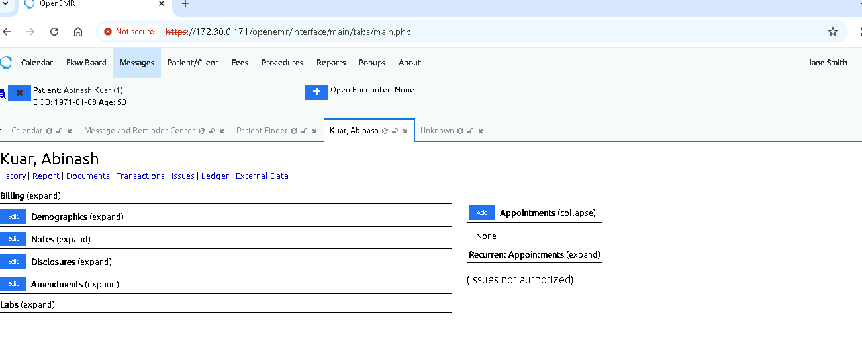

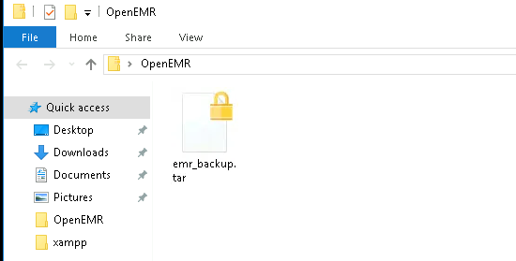

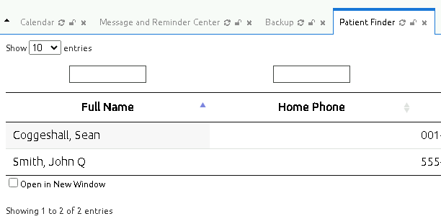
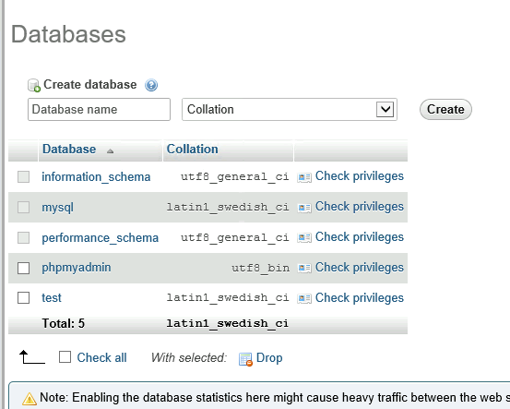
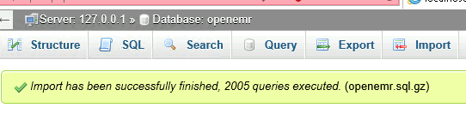
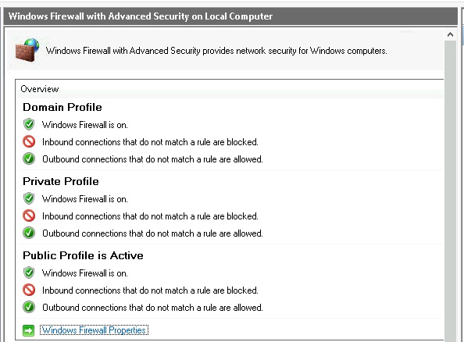
Document the password you used to create the Employee account: 123456


